College of Saint Benedict & Saint John’s University

Computer Science Department

eSaint Aution System (eSAS)

Phase 2: Database Design

Team Name: Rahal Rampagers

Justin Springer, Katie Kutzke, Phil Nowak, Tsuehue Xiong

9/22/2013

**Table of Contents**

EER Diagram……………………………………………………………………………………………………………………….……..3  
EER Diagram Explanation…………………………………………………………………………………………………………..4  
Relational Schema Diagram……………………………………………………………………………………………………….5  
Relational Schema Diagram Explanation…………………………………………………………………………………...6  
Task Decomposition…………………………………………………………………………………………………………………..7  
Meeting Minutes……………………………………………………………………………………………………………………….8  
 Meeting 4……………………………………………………………………………………………………………………….8  
 Meeting 5……………………………………………………………………………………………………………………….9  
 Meeting 6……………………………………………………………………………………………………………………….9  
 Meeting 7…………………………………………………………………………………………………………………….10  
 Meeting 8…………………………………………………………………………………………………………………….11

**EER Diagram**

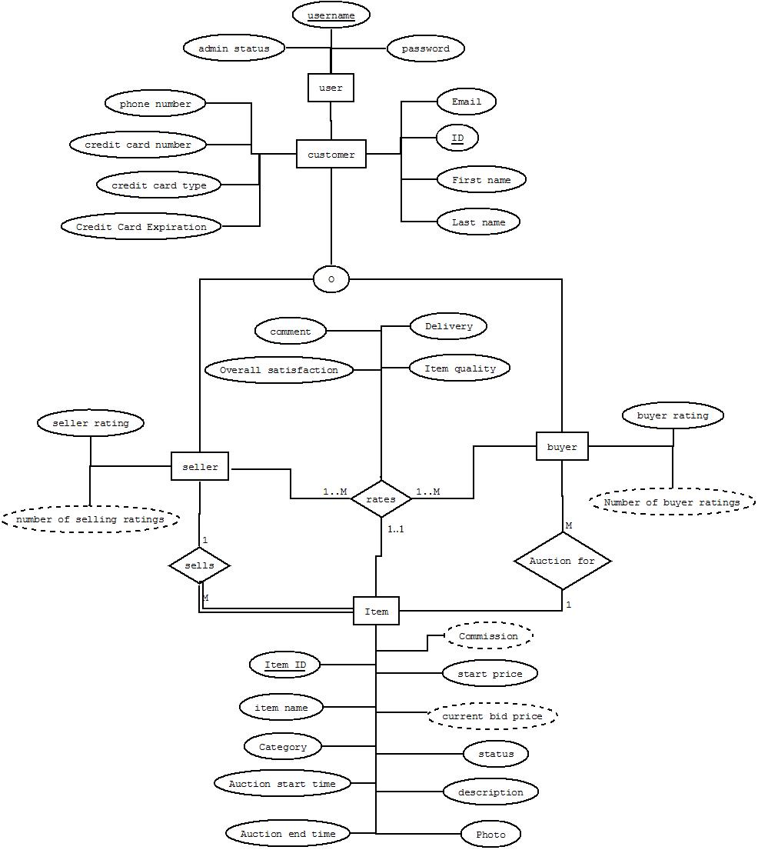

**EER Diagram Explaination**

For our User entity, we gave it an admin status attribute to flag whether or not the user is an admin. Admins do not have any other attributes besides usernames and passwords so we feel this is the best way to distinguish between admins and customers.

We chose to make Seller and Buyer subclasses of customer in order to handle the rating relationship. This allows us to more easily keep track of seller and buyer ratings for each individual customer. Because seller and buyer ratings have different fields depending on who is giving the rating, this subclass setup makes sense for our ER diagram.

The Item entity participates in an “auction for” relationship with buyer. We decided to make the auction a 1:M relationship because there can be multiple bidders on one item during the auction. The item has a unique item ID and can only be in one auction—if it is relisted, it gets a new item ID.

We made the rates relationship between Buyer, Seller and Item a ternary relationship. This makes it clear that each rating needs a buyer, seller and item. The rates relationship has Item ID as a key. This is because each buyer and seller can rate each other over the transaction of one item. Because an item can only be auctioned once, the item ID will be unique in each of the buyer and seller ratings.

**Relational Schema Diagram**



**Relational Diagram Explaination**

We mapped the User entity into the User relation. Username is the key. IsAdmin is a flag determining whether or not the user is an admin.

Customer is a subclass of User that contains all the information that customers have that admins don’t. It has cID as a key, and username is a foreign key pointing back to User.

We merged the Seller and Buyer subclasses in with Customer for our relational diagram. We dealt with the ratings by putting the seller and buyer ratings in their own tables and deriving the average rating/number of ratings.

We modeled the ternary “rates” relationship as two relations, SellerRatings and BuyerRatings. Each rating table stores information about the rating for the seller or buyer-item pair. Because the seller and buyer rate different things, we made it into two tables to reduce nulls. SellerRatings and BuyerRatings each have ItemID as a key as well as a foreign key to Item, because an item can only be sold and bought one time, thus only rated one time per seller and buyer pair.

The Item entity was mapped as the Item relation. We handled the 1:M relationship between Seller and Buyer with the foreign key method because every item is sold by one seller.

The Auction relation handles the 1:M relationship between Buyer and Item. Because the M side is not total, we made Auction its own table. This table contains the ItemID and the bidderID as foreign keys, and the buyer’s max bid.

**Task Decomposition**

Justin:  
-Checked out Eclipse CVS  
-Updated the Website Map Diagram  
- Worked on creating the Relational Schema  
-Reviewed the EER Diagram and the Relational Schema Diagram

Katie:  
-Worked on creating the “missing” pages  
-Worked on creating the Relational Schema  
-Created and revised the Relational Schema Diagram  
-Reviewed the EER Diagram and the Relational Schema Diagram  
-Worked on putting the Report together

Phil:  
-Worked on creating the EER Diagram  
-Created the EER Diagram on DIA  
-Reviewed the EER Diagram and the Relational Schema Diagram

Tsuehue:  
-Note-taker  
-Worked on creating the EER Diagram  
-Reviewed the EER Diagram and the Relational Schema Diagram  
-Worked on putting the Report together

**Meeting Minutes**

**Meeting 4 (9.13.2013) (5:00pm – 6:00pm)**  
**Attendance:**Justin Springer (here)  
Katherine Kutzke (here)  
Philip Nowak (here)  
Tsuehue Xiong (here)  
  
**Notes:**-Ask if you can have a USER that’s both an Admin and a Customer  
-Ask if there is a relationship between Admin and Customer  
-Ask if we need to update our UI diagrams

**HW:**  
-Justin will look into Eclipse CVS  
-Justin will update the Website Map Diagram  
-Katie will work on creating the “missing” pages  
-Phil work on creating the EER Diagram  
-Tsuehue work on creating the EER Diagram  
-Tsuehue is the notetaker

**Summary:**  
-Go over Phase1 report

**Meeting 5 (9.13.2013) (5:00pm – 6:00pm)**  
**Attendance:**Justin Springer (here)  
Katherine Kutzke (here)  
Philip Nowak (here)  
Tsuehue Xiong (here)  
  
**Notes:**-Bidding list doesn’t show enough details, if there can be multiple entries for one bidder just one

**HW:**  
-Kaite create Relational Schema  
-Justin create Relational Schema  
-Phil will create the EER Diagram on DIA

**Summary:**  
-We went over the EER Diagram and made changes to the diagram  
-Set assignments for next meeting

**Meeting 6 (9.15.2013) (10:30pm – 11:30pm)**  
**Attendance:**Justin Springer (here)  
Katherine Kutzke (here)  
Philip Nowak (here)  
Tsuehue Xiong (here)  
  
**Notes:**-Bidding list doesn’t show enough details, if there can be multiple entries for one bidder just one

**HW:**  
-Everyone: Go over the two diagrams and make any changes that see fit

**Summary:**  
-We went over the Relational Schema and made changes to the diagram  
-Decided that we will make the written report together  
-We decided on Katie’s Relational Diagram  
-Set assignments for next meeting

**Meeting 7 (9.22.2013) (10:30pm – 11:30pm)**  
**Attendance:**Justin Springer (here)  
Katherine Kutzke (here)  
Philip Nowak (here)  
Tsuehue Xiong (not here, had on-call work)  
  
**Notes:**-Clarify number 2 and 3 are the same for Phase 2 project requirement  
-Clarify number 4 for Phase 2 project requirement

**HW:**  
-Justin will talk to Tsuehue about what he missed and he will review the CURRENT report  
-Tsuehue will put the rest of the report together  
-Katie will rearrange the arrows in the Relational Diagram to make the diagram easier to understand

**Summary:**  
-We went over the requirements of Phase 2  
-We went over the Relational Schema and made changes to the diagram  
-We started on putting the report together  
-Katie wrote the explanations  
-Phil and Justin reviewed the explanations

**Meeting 8 (9.24.2013) (10:50am – 11:10am)**  
**Attendance:**Justin Springer (here)  
Katherine Kutzke (here)  
Philip Nowak (here)  
Tsuehue Xiong (here)  
  
**Notes:**

**HW:**  
 -Tsuehue will finish putting the rest of the report together

**Summary:**  
-We went over the requirements of Phase 2  
-We finished all the requirements for Phase 2